

Nokia 1208

Description
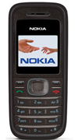
The Nokia 1208 is a small candy-bar style phone. Affordable and easy-to-use, with handy One Touch shortcut keys, unique cost management features, and a vibrant color display screen to make your connections hassle-free.

STORE PRICE: Rs 1,558 /-
ONLINE PRICE: Rs 1,442 /-

Brand : Nokia
Model Name : 1208
Released Year : 2007
Phone Memory : 200 phonebook memory
External Memory : No
Colors : Red, Black
Form : Bar
Dimensions : 102 x 44.1 x 17.5 mm
Weight : 77g

